A **decision tree** is a flowchart-like **tree** structure where an internal node represents feature(or attribute), the branch represents a **decision** rule, and each leaf node represents the outcome. The topmost node in a **decision tree** is known as the root node.

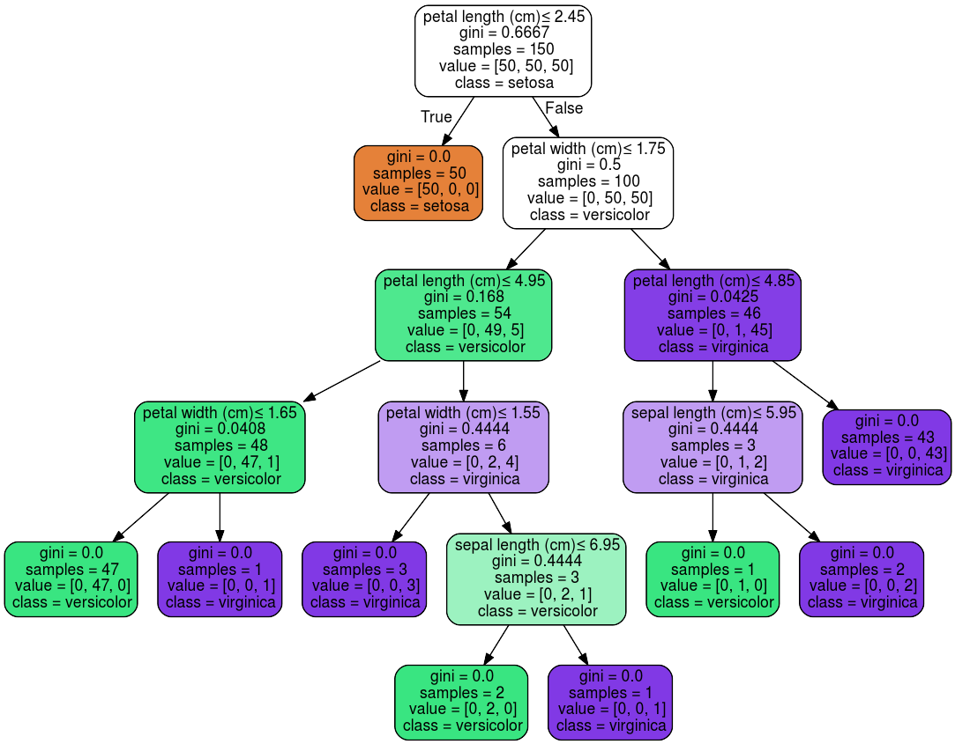

Decision tree for iris dataset

It can be seen that the tree is used to classify the flower into three classes **SETOSA , VERSICOLOR AND VIRGINICA**.

Decision trees are often used while implementing machine learning algorithms. The hierarchical structure of a decision tree leads us to the final outcome by traversing through the nodes of the tree. Each node consists of an attribute or feature which is further split into more nodes as we move down the tree.

But how do we decide which attribute/feature should be placed at the root node, which features will act as internal nodes or leaf nodes? To decide this, and how to split the tree, we use splitting measures like Gini Index, Information Gain, etc.

We will learn how the Gini Index can be used to split a decision tree. Before starting with the Gini Index, let us first understand what splitting is and what are the measures used to perform it.

### **What are splitting measures?**

With more than one attribute taking part in the decision-making process, it is necessary to decide the relevance and importance of each of the attributes, thus placing the most relevant at the root node and further traversing down by splitting the nodes. As we move further down the tree, the level of impurity or uncertainty decreases, thus leading to a better classification or best split at every node. To decide the same, splitting measures such as **Information Gain, Gini Index, etc**. are used.

### **What is Information Gain?**

Information Gain is used to determine which feature/attribute gives us the maximum information about a class. It is based on the concept of entropy, which is the degree of uncertainty, impurity or disorder. It aims to reduce the level of entropy starting from the root node to the leave nodes.

**Formula for Entropy**

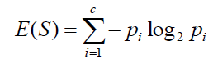

‘*p*’, denotes the probability and E(S) denotes the entropy. Entropy is not preferred due to the ‘log’ function as it increases the computational complexity.

### **What is Gini Index?**

Gini index or Gini impurity measures the degree or probability of a particular variable being wrongly classified when it is randomly chosen. But what is actually meant by ‘impurity’? If all the elements belong to a single class, then it can be called pure. The degree of Gini index varies between 0 and 1, where 0 denotes that all elements belong to a certain class or if there exists only one class, and 1 denotes that the elements are randomly distributed across various classes. A Gini Index of 0.5 denotes equally distributed elements into some classes.

Formula for Gini Index

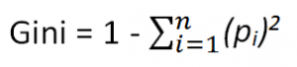

where *pi* is the probability of an object being classified to a particular class.

While building the decision tree, we would prefer choosing the attribute/feature with the least Gini index as the root node.